Review!

* <https://docs.google.com/forms/d/e/1FAIpQLSdsaZEF5hR2LWeC-7Xw3lrverrDgpqe5vxenx6S5x4pAdKyvg/viewform?usp=sf_link>

First new thing: Functions

* Here is what they look like: cool_function(x, y)
* x,y are arguments that can be passed into the function
* use variables to explain

Operators: Put into function

* +, -, *, /, %, ++, --
* + can also be used to concatenate strings
* You can put equals after anything
  + +=, -=, etc

Styles!!

* Use spaces

Conditionals

* 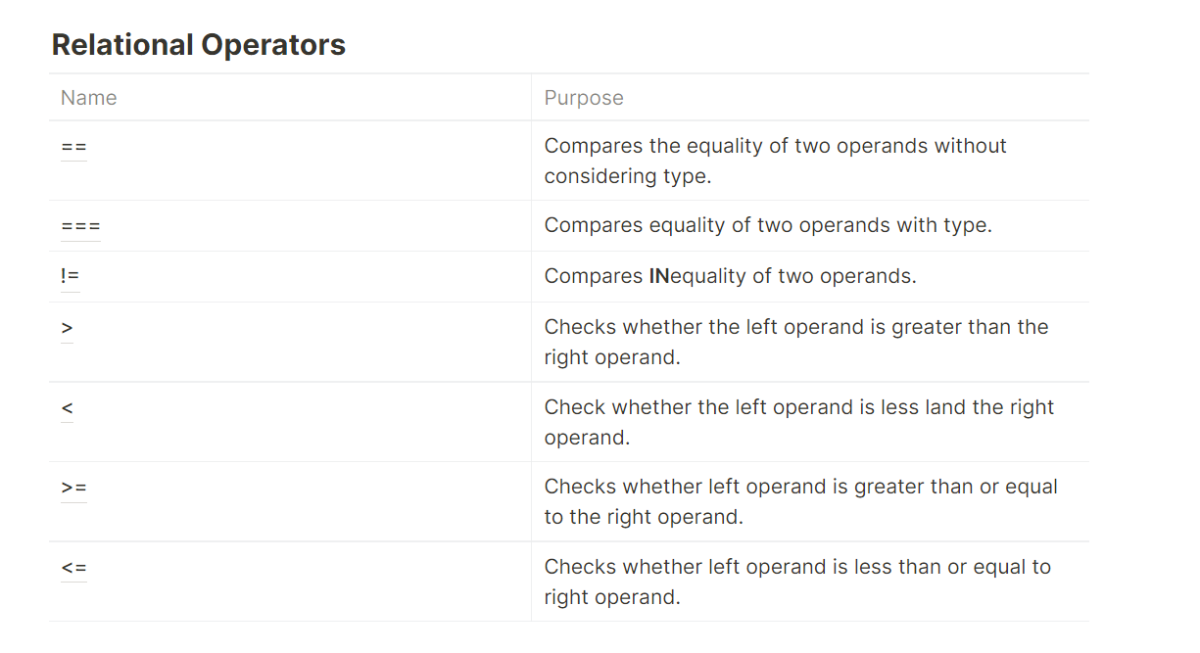
* 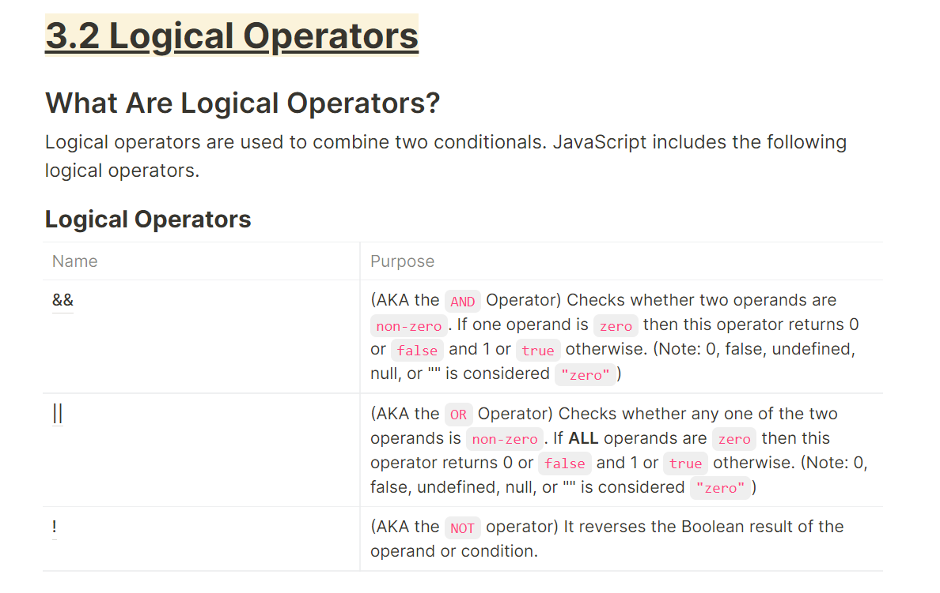

If statements

* Used to control which parts of code run
* If else

One liner if statements: ternary operator

* I love this thing
* Super clean

Switch statements

* 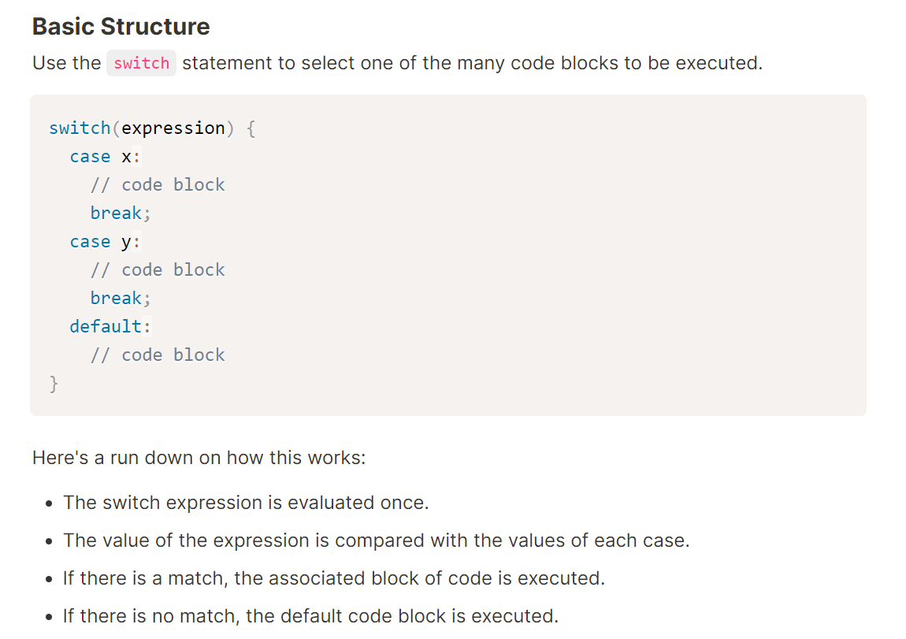
* Break statement is super important. If you don’t break, the switch statement will just keep executing code
* Default: if no cases are matched, this is what runs

Project:

* Use website and switch cases to display the name of the week based on what number you enter.
  + Make sure to use default case
* Remember to make scaffolding